Management Medicine Cabinet

Sharepoint Concept

**1. Landing Page**  
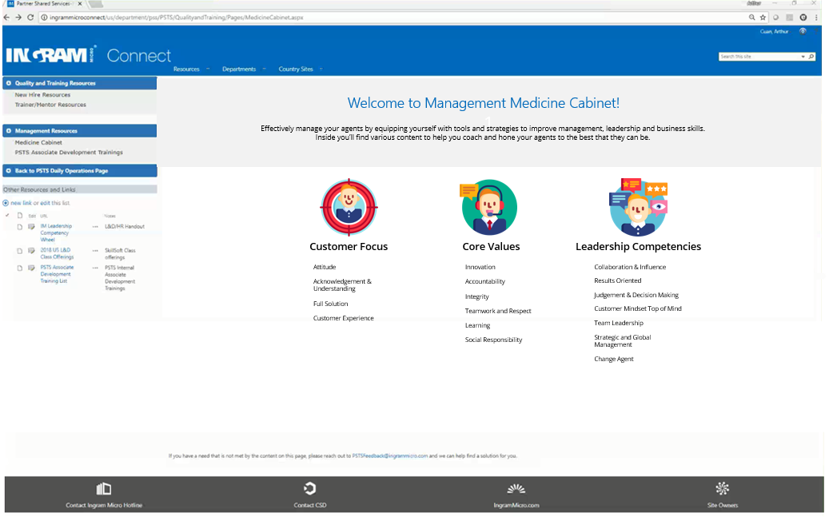Clicking an icon of interest will route to respective page.   
  
  
2. Sample Page: Clicking on Leadership Competencies > Customer Mindset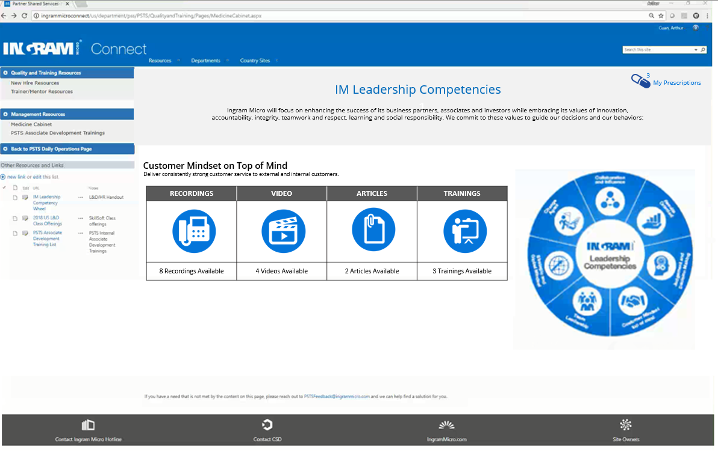  
  
3. Sample Page: Clicking on Core Values > Innovation

**. HOME .**

Total number of content available are shown

Leadership Competencies Wheel for Visual Reference

Outlined Facets of each Category.   
Each is clickable.

Clickable Icon Designs for Visual Reference

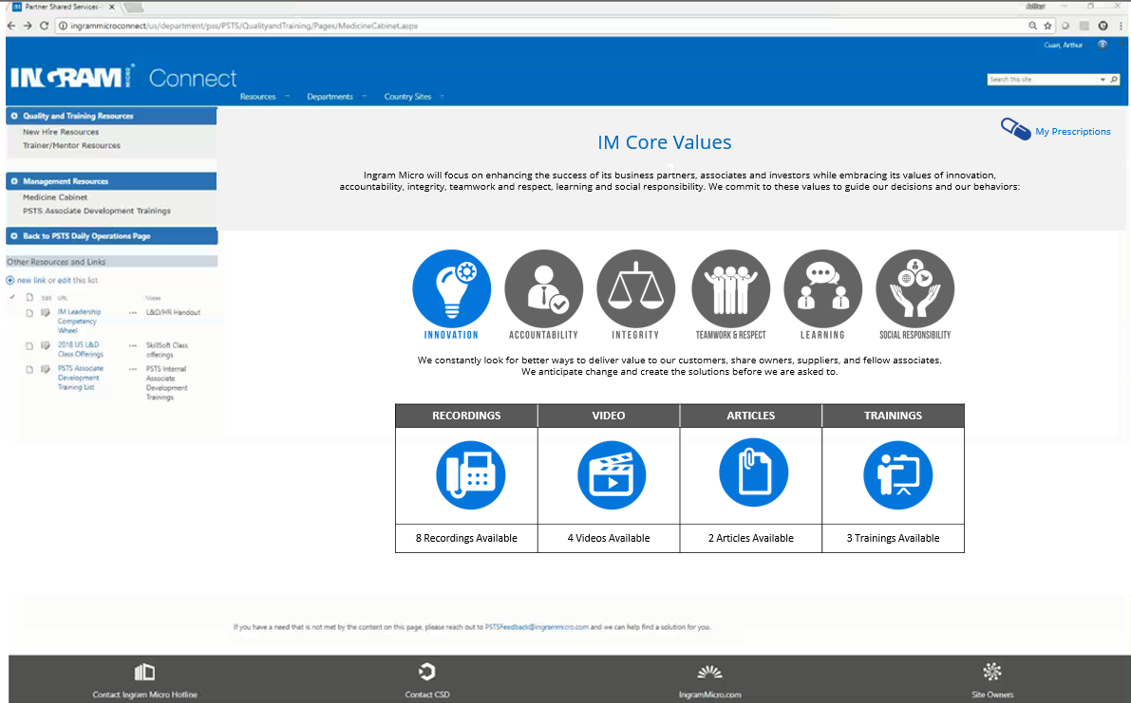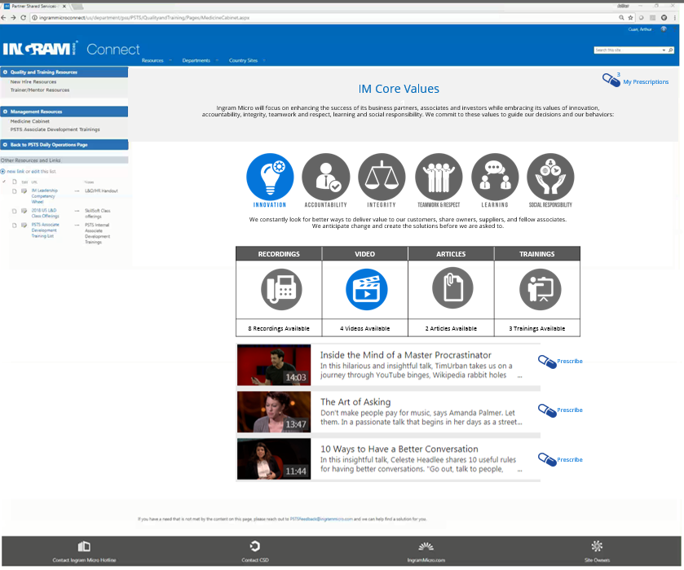  
  
4. My Prescriptions Page  
  
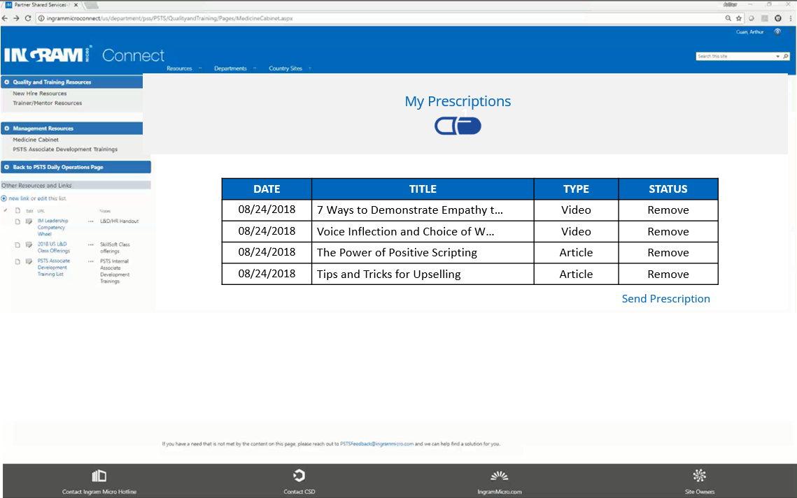  
Upon clicking on the “My Prescriptions” Icon, managers will have a view of all the content they have “prescribed”. This prescription can then be sent to a specific technician based from his/her needs as assessed by the respective manager. Managers can personalize prescription prior to sending them out. Future option is for a manager to save handpicked contents and put a title to the mix for an easier and faster way to send prescriptions for common coaching points.

Managers can click “Prescribe” icon to save content on the “My Prescriptions”.

Clicking on an Icon will show content

“My Prescriptions” icon

Icons are highlighted. Each are clickable on this page.